Micro-flaring incineration technology (MIT- technology)

1. MICROFLARE INCINERATION TECHNOLOGY (MIT-technology) provides a qualitative BREAKTHROUGH IN ENERGY SAVING AND ENVIRONMENTALLY FRIENDLY OPERATION OF HIGH-TECH INSTALLATIONS (boilers, gas turbines, heat generators, drying plants, waste heat boilers and other installations) using gaseous fuel (natural gas, hydrogen H2, biogas, converter gas, blast furnace gas, synthesis gas, mixtures of any gases) due to the presence of a complex of positive effects.

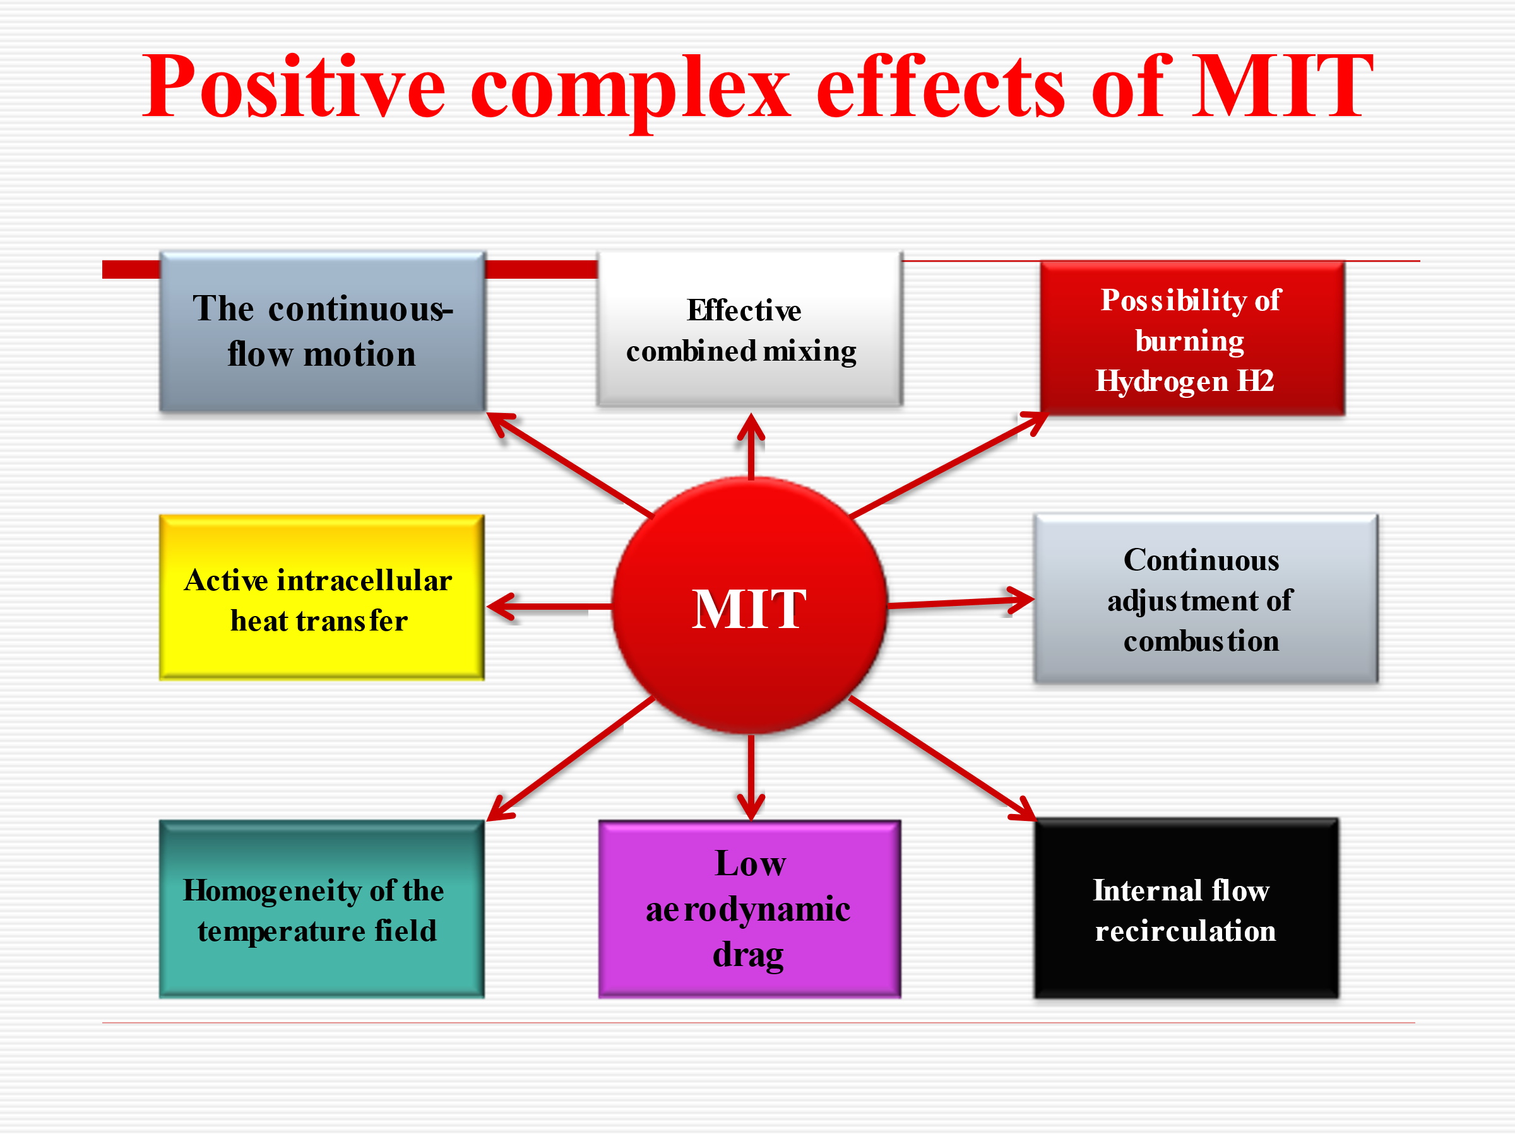
2. USING MTS Technology is advisable in the following cases:
1 - Creation of new burner devices for any gaseous fuel combustion installations;
2 - Modernization of burner systems of existing installations (boilers, gas turbines, waste heat boilers, furnaces, drying units, etc.)
The use of MTS burners is especially effective for modernizing power plants, which allows for:
- high fuel economy rates;
- significant reduction in the concentration of leading components;
- quick return on investment;
- increasing the effective service life and service life of equipment.
Our aim is pure environment!
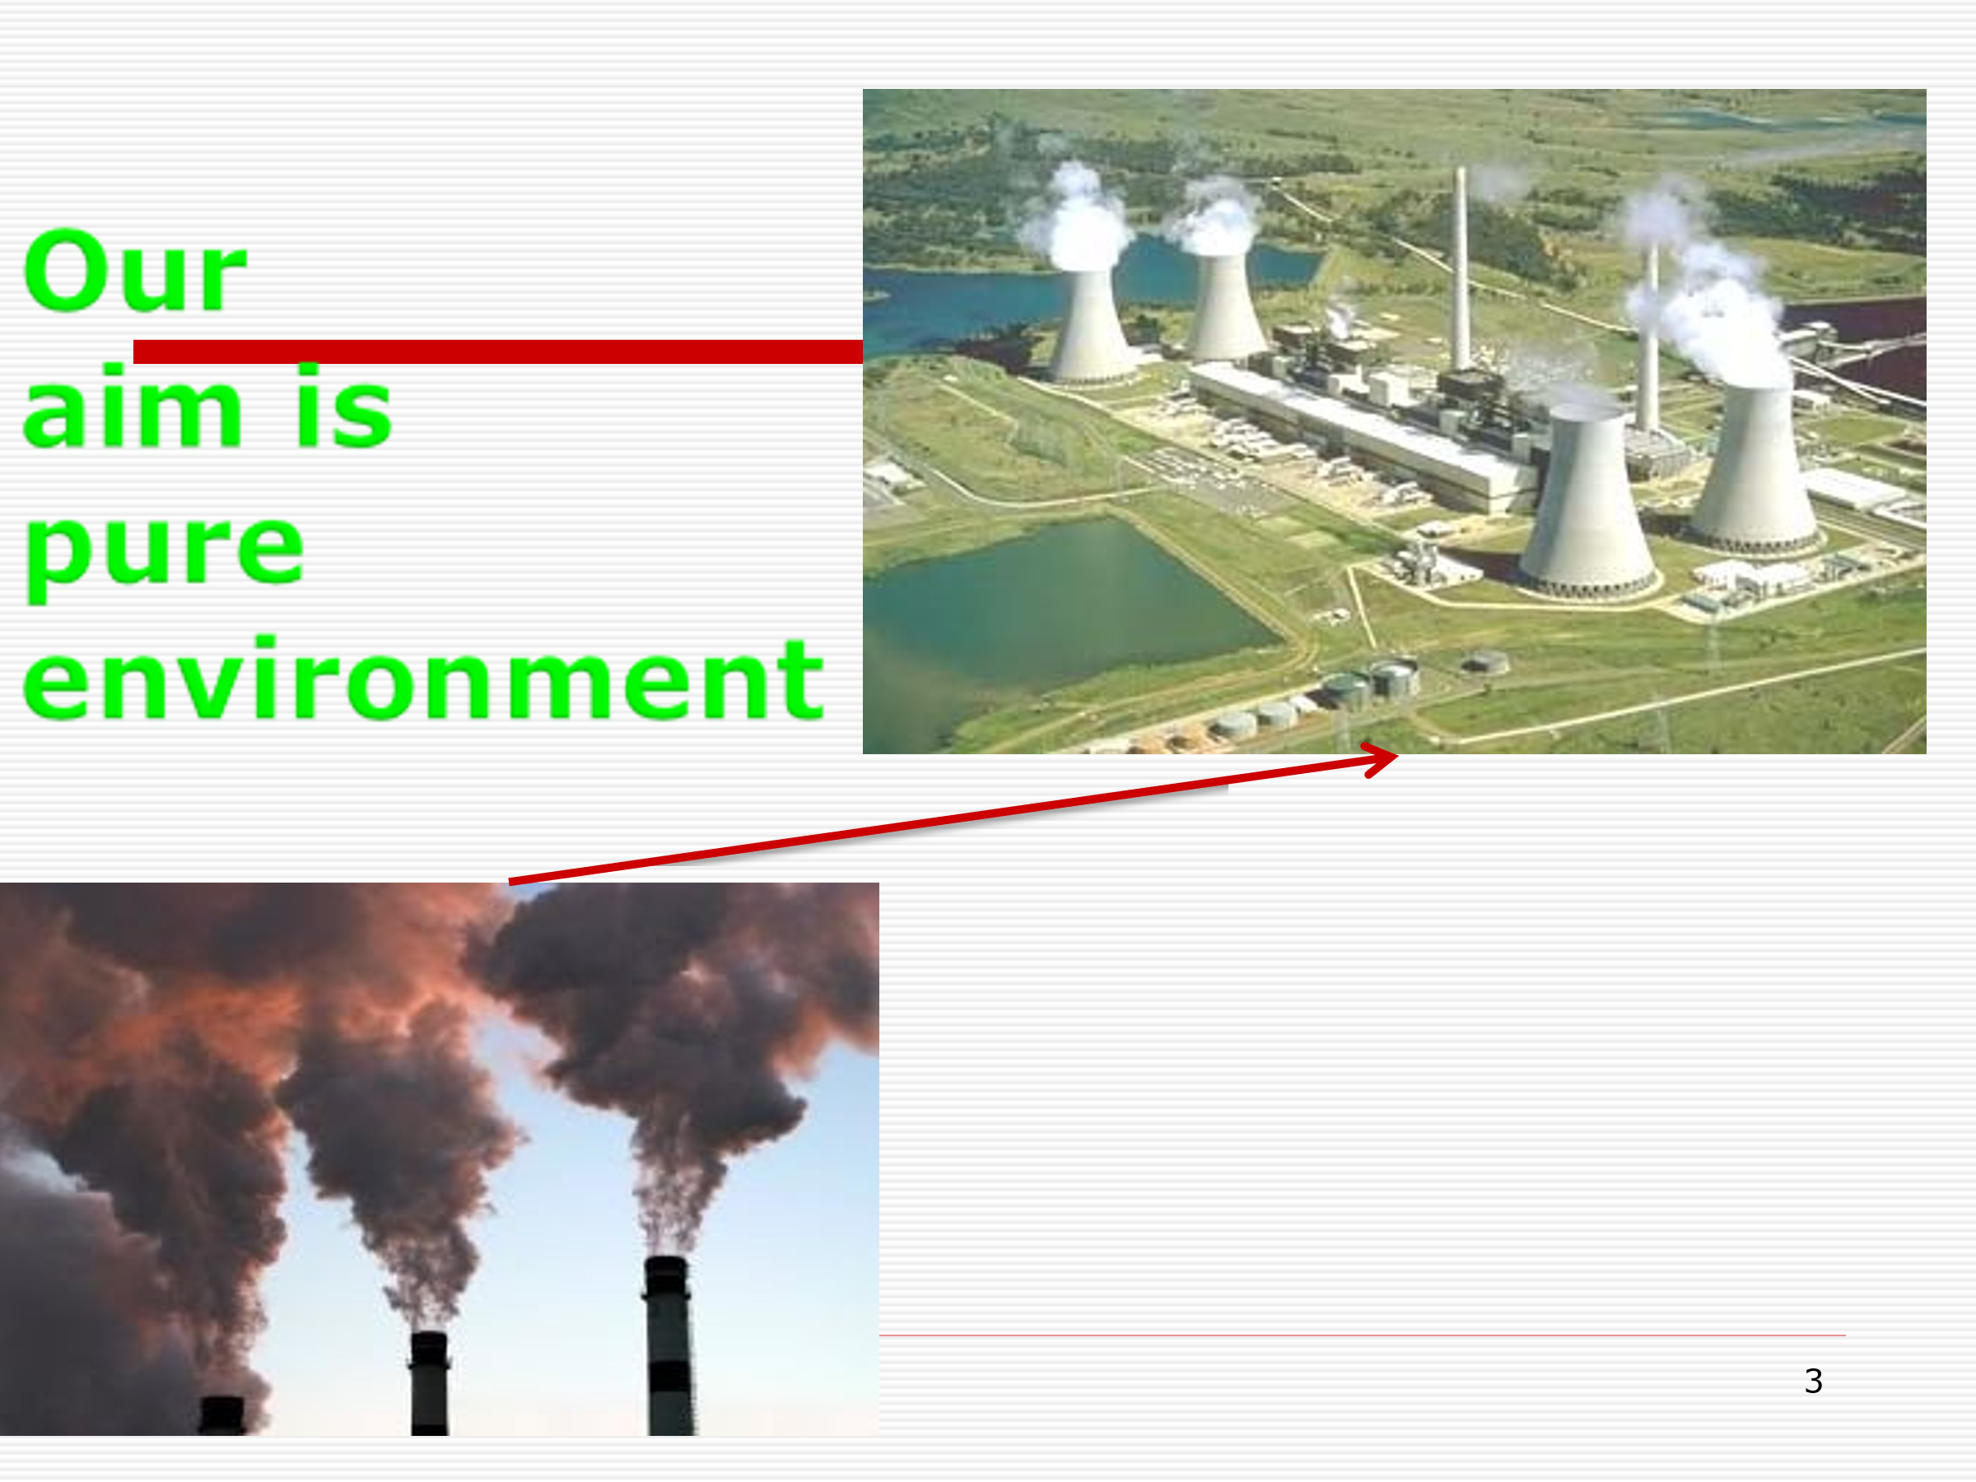

3. Generalized NOx and CO emission characteristics (air speed ~25 m/s)

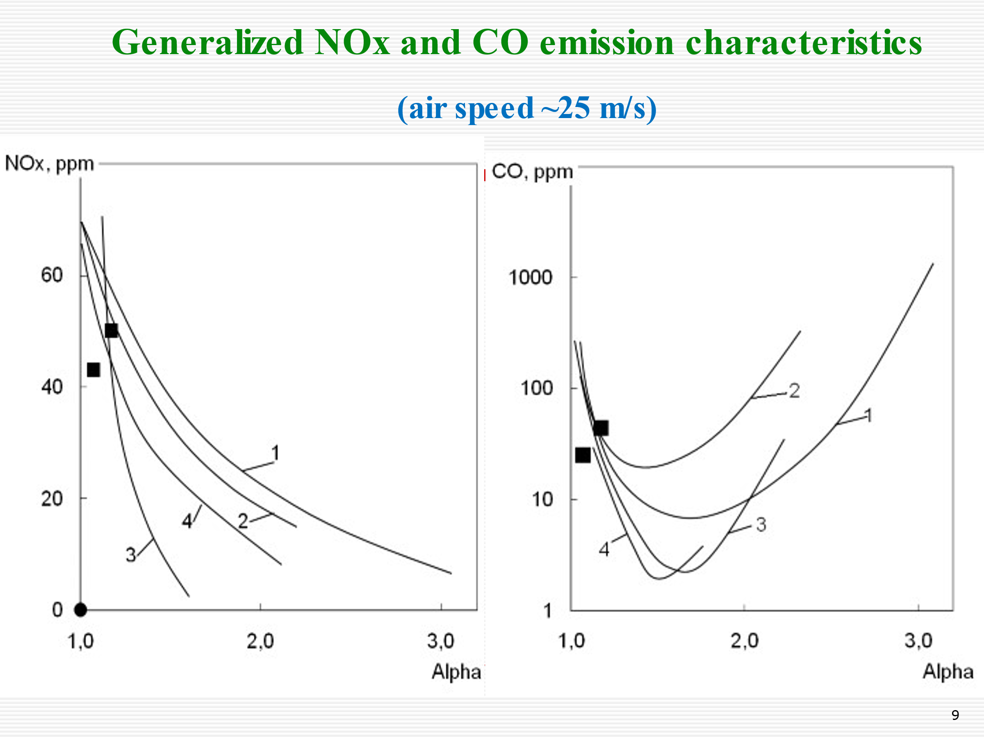

4. Flame structure of MIT- burners with different nozzles and types of mixture formation

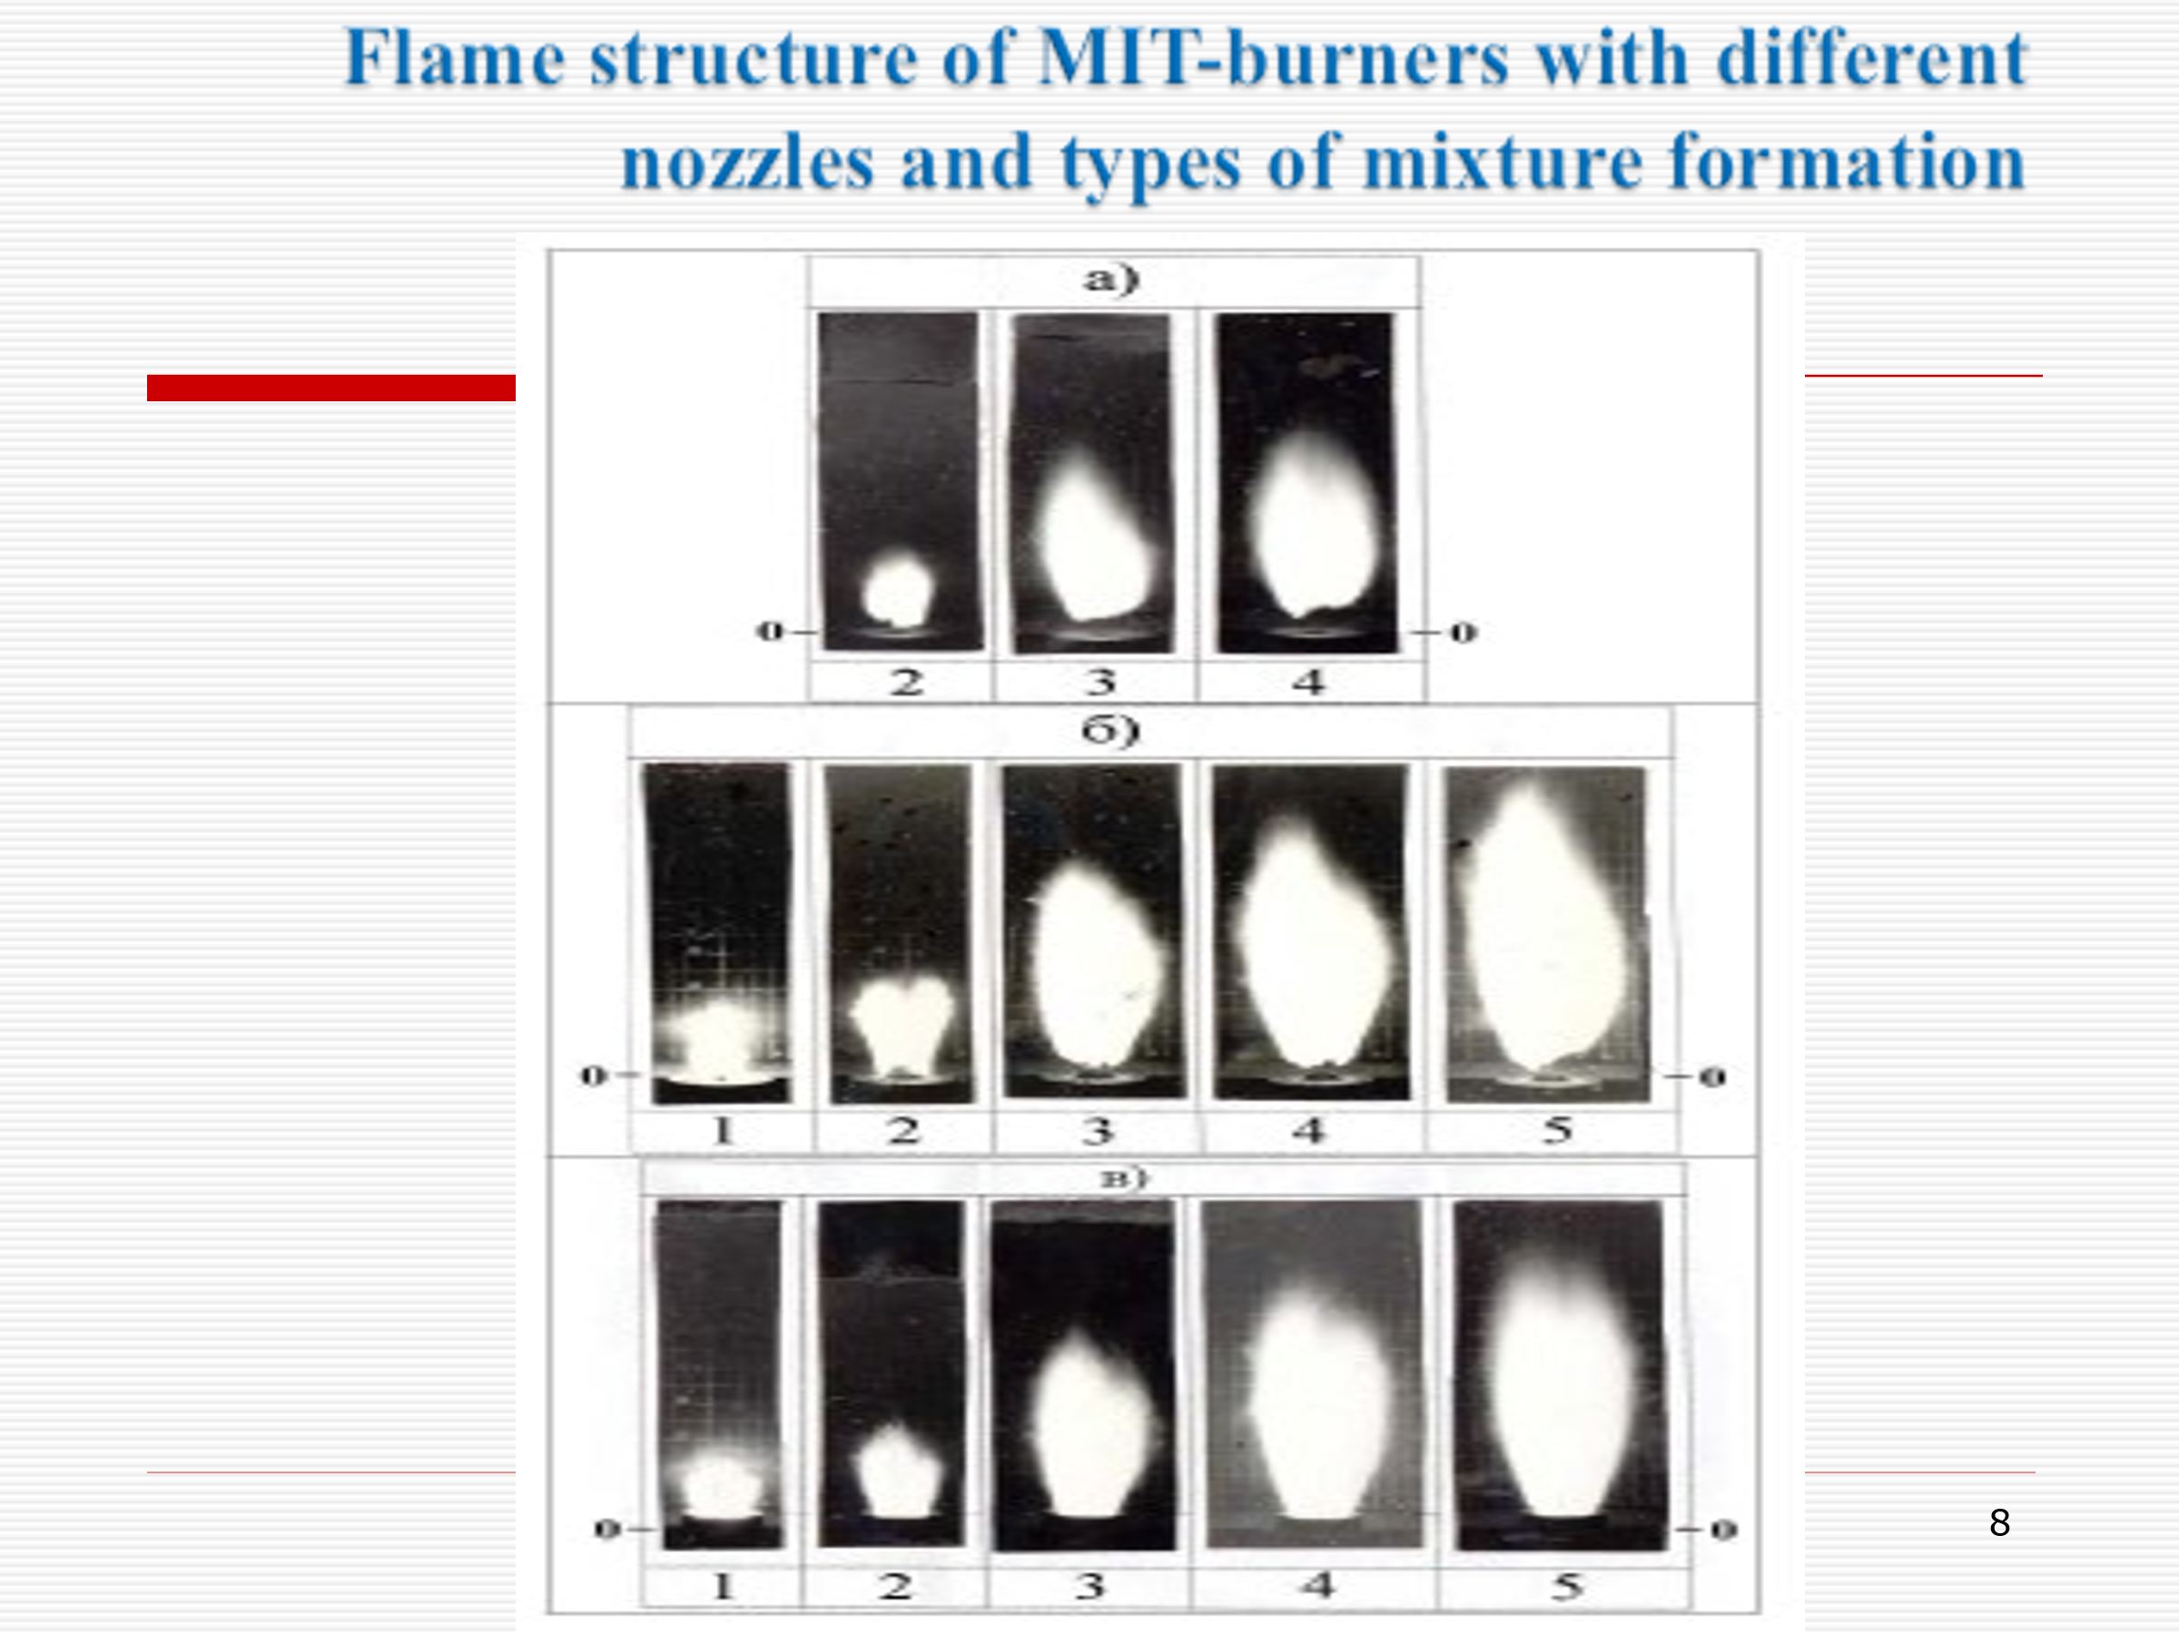

5. The graphs clearly show the main positive features of the boundary characteristics of
MIT- burners
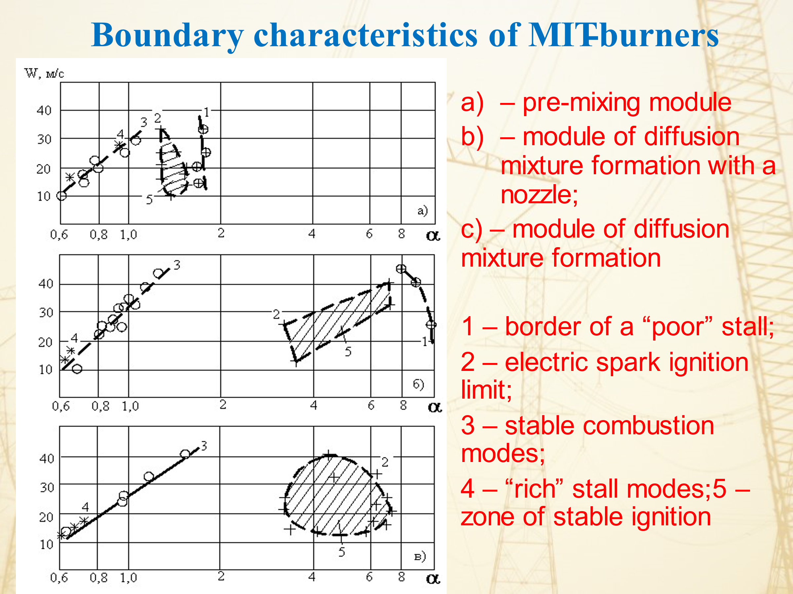
6. In MIT-burner a reduction in NOx and CO emissions is achieved due to:
- combined mixture formation - by 20...30%;
- stage combustion - by 20...30%;
- direct flow (reducing the time the mixture remains in the combustion zone) - by 20%.

7. General view of a universal interchangeable MIT- burner for a 20 MWt boiler and a 6 MWt gas turbine with high levels of environmental cleanliness of combustion (same overall dimensions, but different combustion conditions due to different excess air ratios)

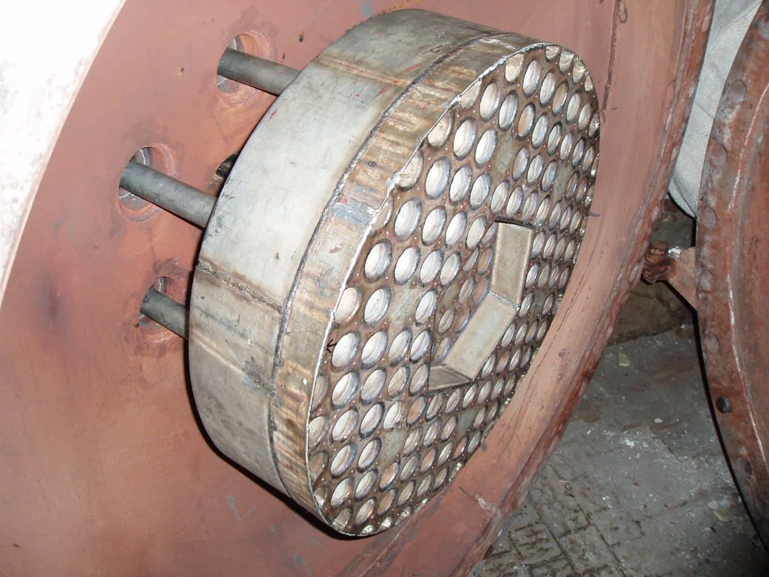

8. Appearance of the MIT- burner for a gas turbine
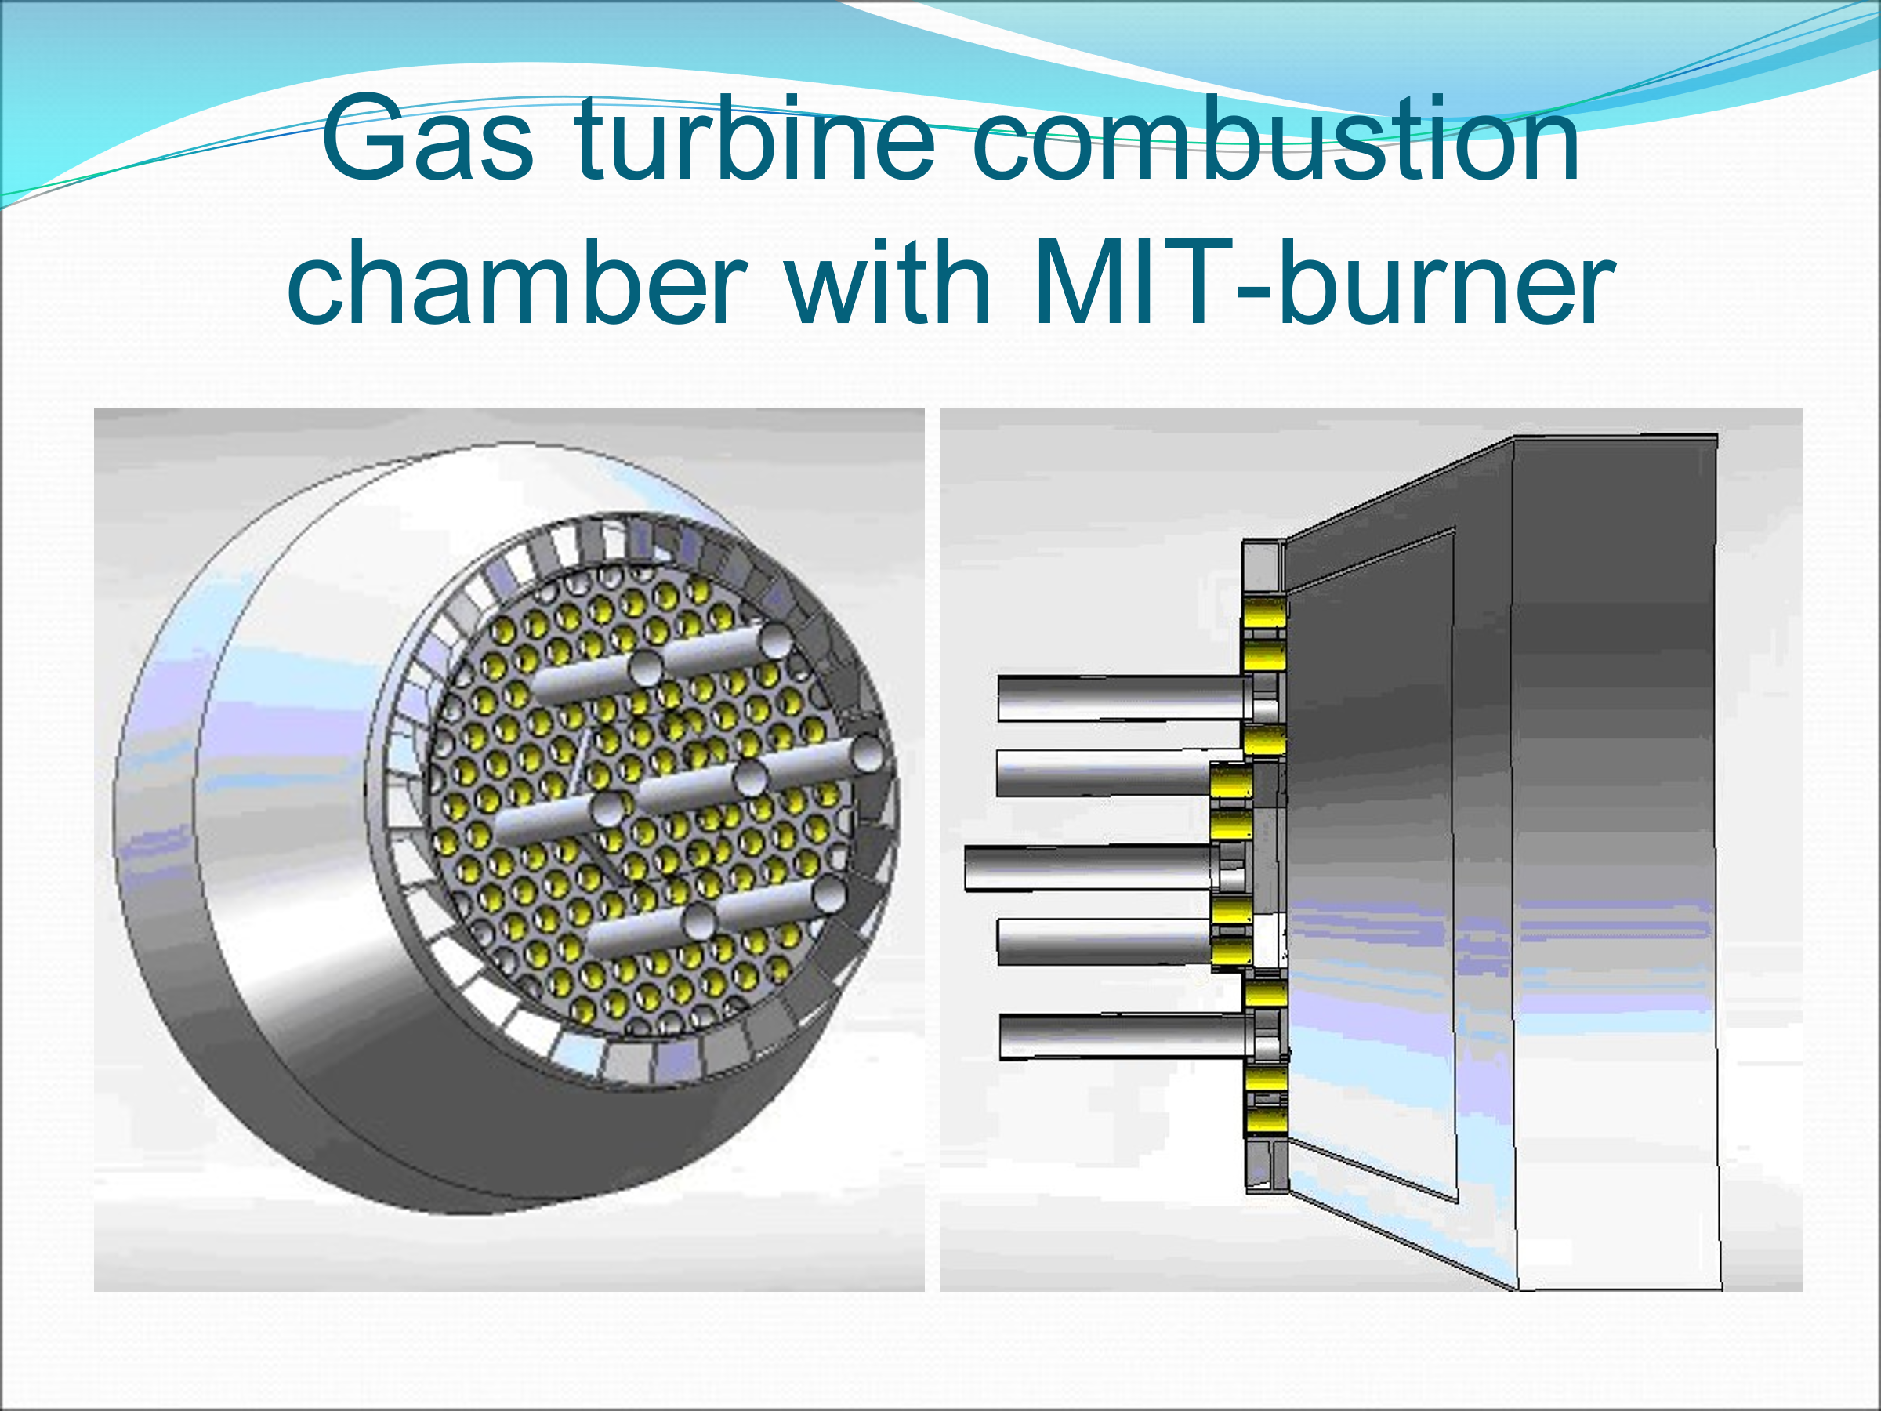
9. Velocity field of the MIT-burner
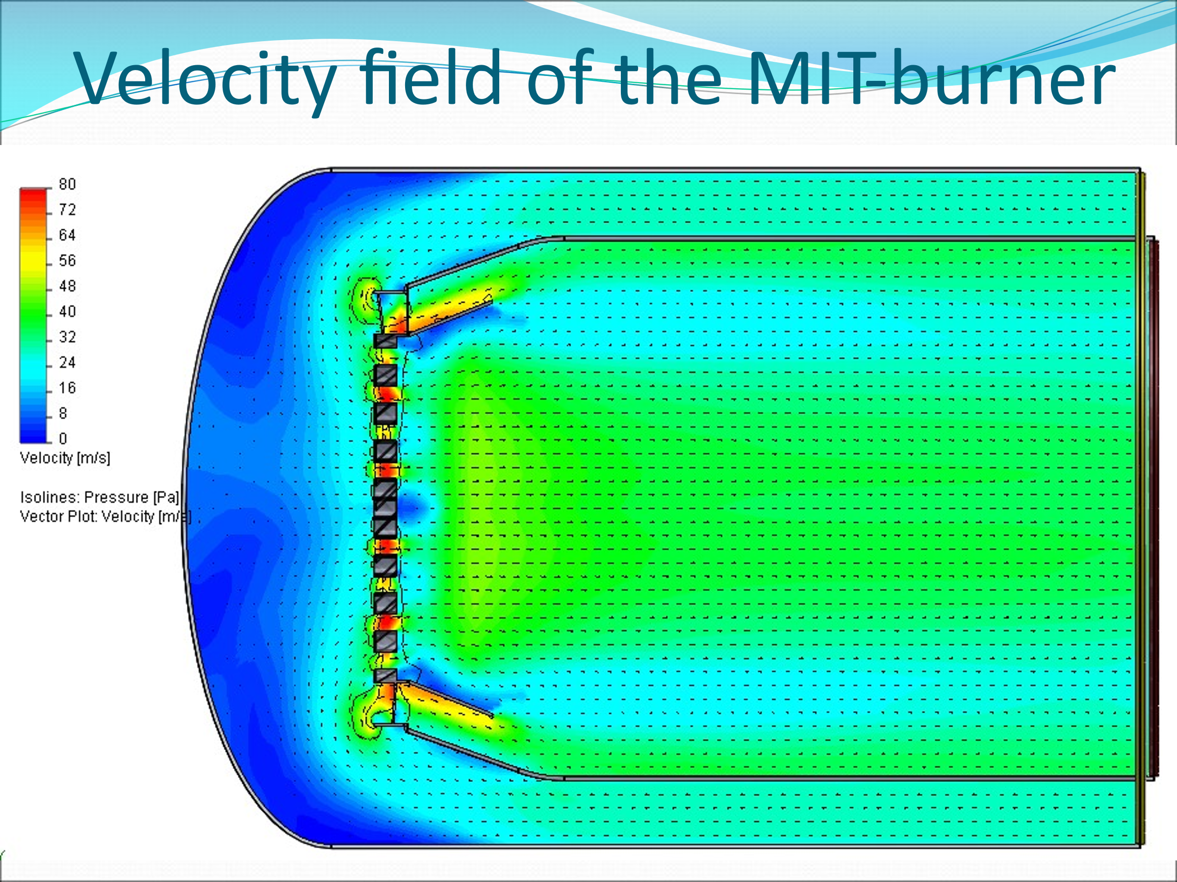
10. Temperature field of the MIT- burner
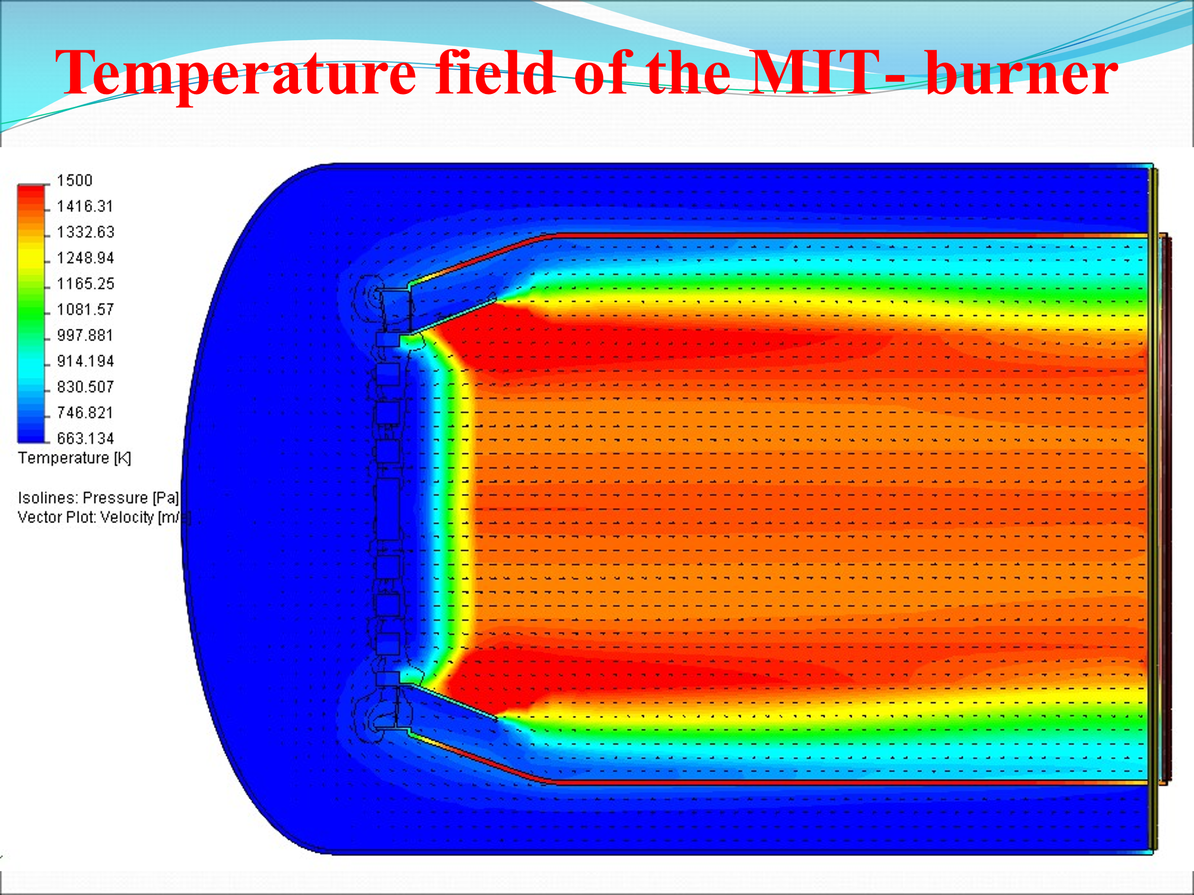

11. The operation of a combustion chamber with an MIT- burner is characterized by a set of positive advantages that increase the energy and environmental performance of the combustion chamber and the entire gas turbine unit:
1 - The increase in efficiency is - 3.5 - 5.5%
2 - Fuel economy:
- in boilers - 5...6%;
- in a gas turbine - 10...12%;
- in contact heat generators - 10...14%;
3 - Reduction of harmful emissions is:
- nitrogen oxides NOx – 3...5 times (up to 50-95 mg/m3)
- CO oxides - 8...30 times (up to 5 mg/m3)
4 - The increase in engine life is 25,000 ... 45,000 hours
5 - The payback period for modernization is 3...5 months.

12. Comparison of combustion quality in a register-type burner (the most common type of gas burners) and an MIT- burner at the same power
Register burner (before replacing the boiler):

MIT- burner (after replacement in the boiler):
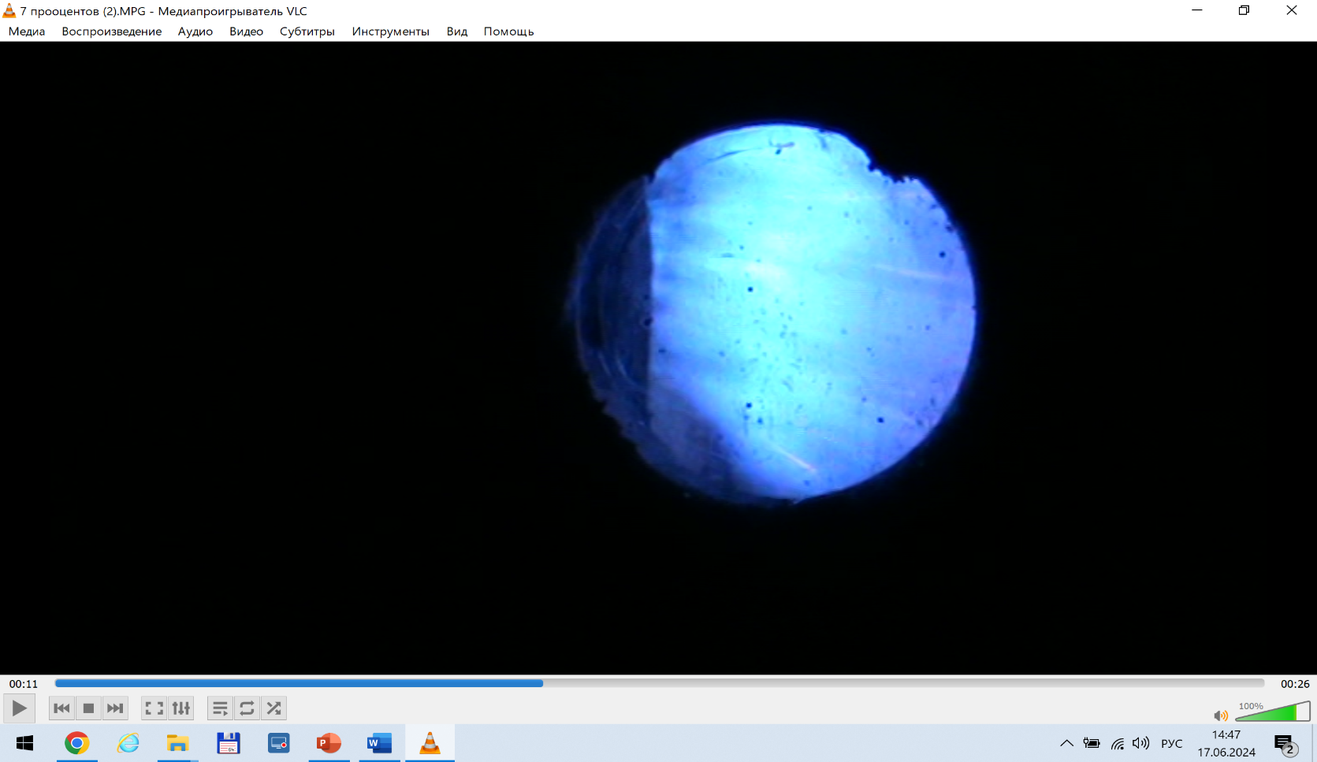

13. Modernization of the burner system in a 20 MW boiler
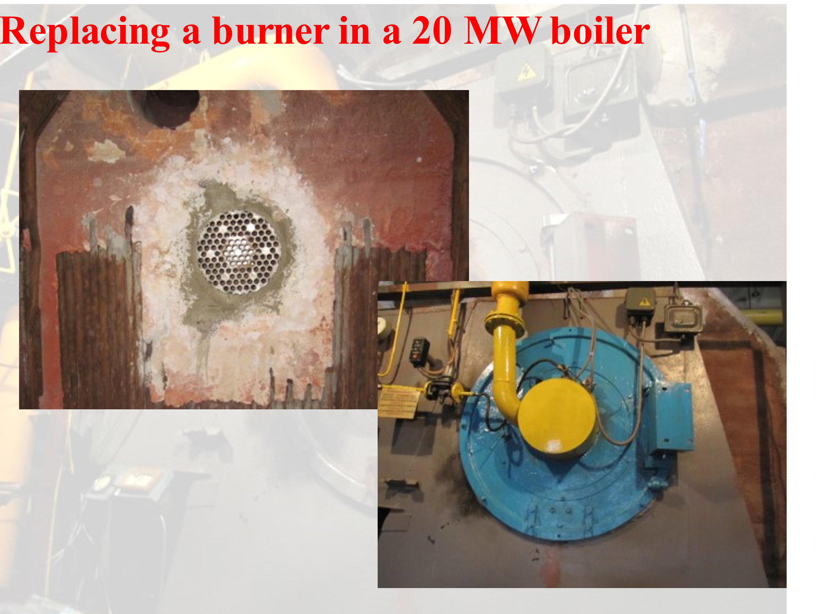

14. View of the MIT- burner torch in the boiler
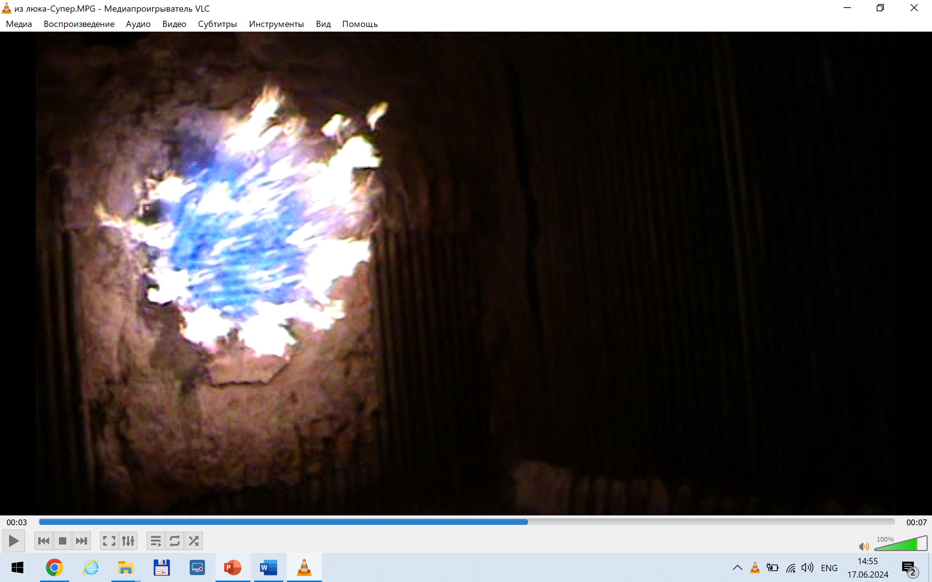

15. View of the MIT- burner torch in the gas turbine combustion chamber
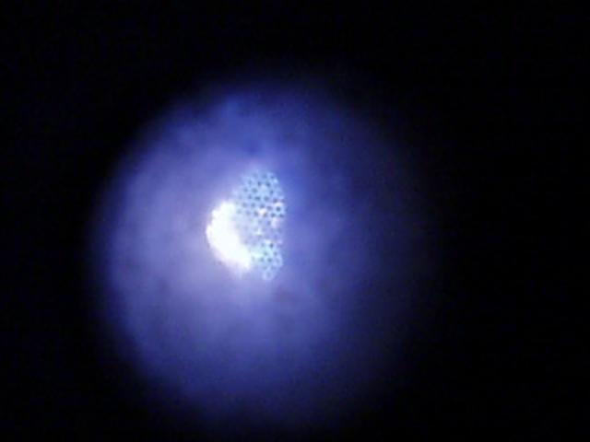

16. The combustion process of a torch in a 9 MW MTS burner in a 180 MW boiler (20 MTS burners)


17. The process of torch combustion in a 35 MWt MIT-burner in a 105 MWt boiler (3-MTS burners)

